OPENAGRINET (OAN) ETHIOPIA PROJECT

Grievance Management Module
Design Document — Architecture, Sequence Flows and API Catalogue
Field | Details
Document Title | Grievance Management Module — Architecture, Sequence Flows and API Catalogue
Project | OpenAgriNet Ethiopia Project
Project Sponsor | Agricultural Transformation Institute (ATI) / Center for Open Societal Systems (COSS)
Prepared By | Protean eGov
Source Documents | Grievance Management Module — Design Document, v0.2 (7 Sep 2026); Grievance Process Architecture, v4 (11 Sep 2026); Functional Specification Document, v1.3 (Aug 2026); Grievance Service and Grievance Web Application repositories
Date | 22 September 2026
Version | 0.3 — Draft for Review
Note on scope. The v0.2 design document deliberately left out the full REST endpoint catalogue. This document supplies it, alongside the component architecture, the three sequence flows, the OpenAPI contract and the API gateway design.

Table of Contents
Section | Title
Overview | Executive Summary (capabilities, user roles and RBAC)
1 | Component Architecture
2 | Sequence Flows
2.1 | Service Category, Department & SLA Configuration
2.2 | Officer Onboarding (L1 / L2 / Department Head)
2.3 | Grievance Submission → Resolution
2.3.1 | Triage outcomes: routing, the manual queue and rejection
2.3.2 | The More Info Needed loop
2.3.3 | Duplicate review
2.3.4 | Referral and reassignment
2.3.5 | The SLA ladder and escalation
2.3.6 | Closure: confirm, reopen, or the window expiring
2.3.7 | Attachment upload and scan verdict
2.3.8 | Anonymity
2.3.9 | SLA deferral
3 | REST API Catalogue
3.1 | Health and monitoring
3.2 | Administrative areas and reference data
3.3 | Case Submission
3.4 | Channel intake webhook
3.5 | Cases — read
3.6 | Cases — lifecycle, actions and communication
3.7 | Attachments
3.8 | Administration — users, organisation and routing
3.9 | Response templates
3.10 | Notification configuration
3.11 | Reports & analytics
3.12 | Case triage & SLA operations
3.13 | Identity, sign-in and session
4 | OpenAPI Specification
5 | API Gateway (Kong) Overview
5.1 | One hop, gateway in front of the platform

Executive Summary
This section is a plain-language overview of the Grievance Management Module. Sections 1 onward add the technical layer — architecture, sequence flows, the endpoint catalogue, the OpenAPI contract and the gateway design.

What the Module Does
The module gives farmers, cooperatives, FPOs, NGOs, and Woreda/Kebele bodies a formal way to raise a grievance about an OAN-enabled agricultural service, and gives ATI, MoA, and partner departments a structured way to receive, act on, and close that grievance — with every step tracked and every submitter kept informed. It supports several ways of reaching the system (mobile app, web portal, IVR/helpline, call-centre or Development-Agent assisted entry, and Telegram), and it never resolves a grievance itself — every outcome is a decision made by a person in a responsible department.

Who Can Do What
Role | Can see / do
Farmer / direct submitter | Only their own grievances: submit, view, respond to information requests, confirm or reopen a resolution, escalate after the SLA has passed
Development Agent (assisted submissions) | Grievances they submitted on behalf of a farmer; the farmer remains the owner, the officer’s identity is kept for audit
L1 Nodal Officer | Cases assigned within their category, department and region: review, update status, respond, request reassignment
L2 Senior Nodal Officer | Same as above, plus approving SLA deferral requests, and reassignment requests in the categories configured to require approval
Department Head | Oversight of their department’s cases and SLA settings
OAN Administrator (ATI) | Full administrative access: users, RBAC assignment rules, SLA policy, notification templates, and audit records (view only — never delete)
The system defaults to denying access. A user must have an active account, the right role, and the case — or an approved administrative scope — explicitly assigned to them before any action is allowed.

1. Component Architecture
Every channel — mobile app, staff UI, IVR/SMS, mail and the Telegram bot — reaches the grievance service through a single API Gateway, so intake, access control and SLA handling stay in one place. A farmer or field agent can raise and track a case through any of the submission channels — mobile app, IVR, email, Telegram, or the web portal directly.
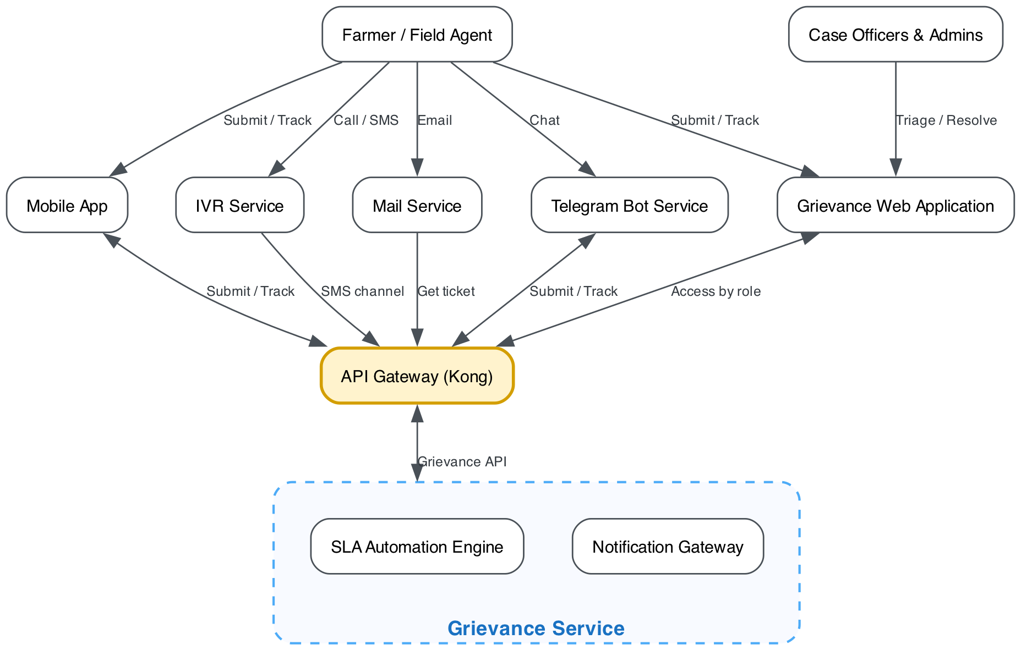
Component architecture of the grievance service
The Telegram Bot Service is two-way because a chat session both submits grievances and reads back ticket status. IVR (SMS intake) and Mail (ticket retrieval) stay one-way into the gateway.
Component | Role
Mobile App | Farmer and field agent submission and tracking
IVR Service | Voice and SMS intake
Mail Service | Ticket retrieval by email
Telegram Bot Service | Submission and tracking over chat
Grievance Web Application | Web portal: case officer and admin triage and resolution, and direct ticket raising by a farmer or field agent
API Gateway (Kong) | Single entry point; routes every channel and applies access rules by role
Grievance Service | Grievance lifecycle, ticketing and status
SLA Automation Engine | Watches SLA clocks and raises reminders
Notification Gateway | Sends status and SLA alerts

2. Sequence Flows
The three processes that actually move data through the module — who calls whom, in what order, and which DocType gets written at each step.

2.1 — Service Category, Department & SLA Configuration
Admin-only, through Grievance Web Application. Four phases, each ending in a write to its own DocType.
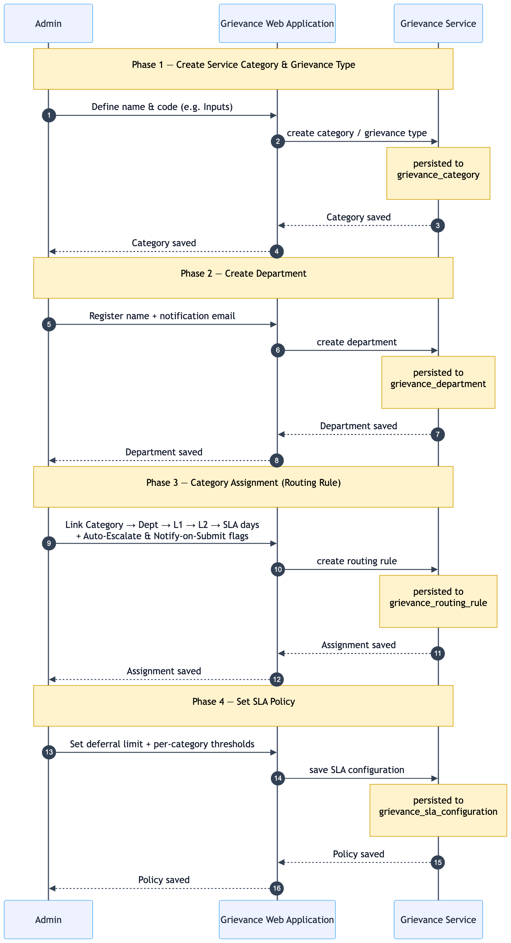
2.1 — Configuration
Solid arrows are requests, dashed arrows are the acknowledgements that follow. Grievance Web Application is the only component that ever calls Grievance Service here — no mobile app, no submitter.

2.2 — Officer Onboarding (L1 / L2 / Department Head)
Internal staff provisioning, separate from the citizen path in 2.3. There is no officer self-registration: the admin creates the account, the service issues a temporary password, and the officer sets their own password at first sign-in. Ends with the new officer selectable in 2.1’s RBAC assignment rules.
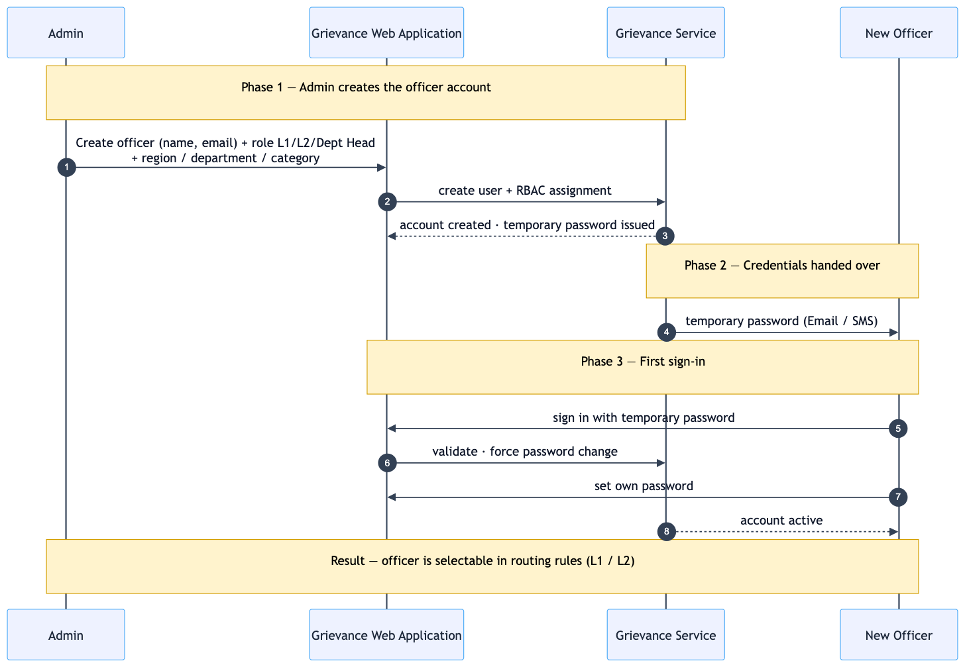
2.2 — Officer onboarding
Role and scope are fixed by the admin at creation time, so the account is already routable the moment the officer finishes setting their password.

2.3 — Grievance Submission → Resolution
The end-to-end case lifecycle. Every component from the architecture diagram appears here at least once, and the SLA clock runs independently for the whole thing. The submitting channel is a recorded attribute of the case, not a separate code path — mobile app, IVR, email and Telegram all converge on the same intake. Escalation and anonymity are overlay flags rather than lifecycle states, so neither ever replaces the status a case is in.
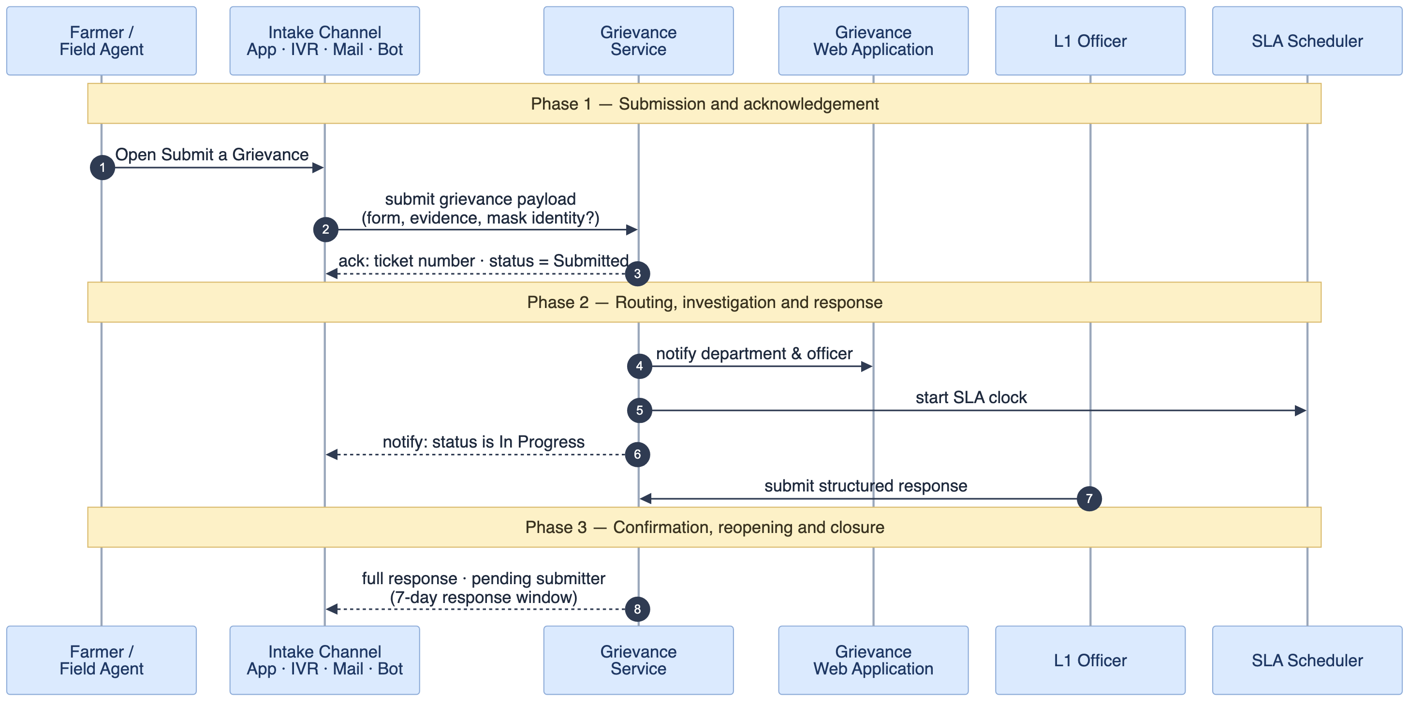
2.3 — Submission to resolution
This is the spine only — the path a case takes when nothing branches. Triage and the Other queue, information requests, duplicate review, referral and reassignment, the SLA ladder, closure, supporting documents and anonymity each branch off it, and each is drawn in the subsections that follow.

2.3.1 — Triage outcomes: routing, the manual queue and rejection
What happens between a case being submitted and an officer holding it. An RBAC assignment match assigns straight through. Everything else — no matching rule, or an IVR call or inbound email that never named a category — is filed under Other, the default service category. Other is a real category with a real queue and a real officer, not a holding pen outside the taxonomy.
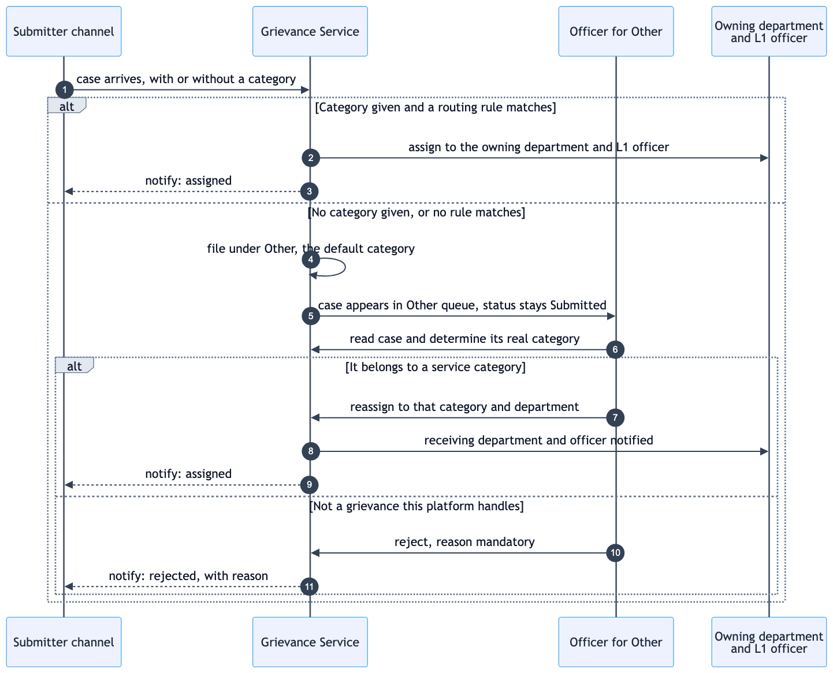
2.3.1 — triage outcomes: routing, the manual queue and rejection
The case stays Submitted while it sits in Other — the queue is not a status of its own. The officer working Other does not resolve these cases; they identify the real category and reassign, which is the same operation as 2.3.4 and follows that category’s approval setting. Rejection carries a mandatory reason, because it is the one triage outcome the submitter has to be able to act on.

2.3.2 — The More Info Needed loop
An officer cannot always act on what was submitted. This is the exchange that fills the gap, and the one branch of it that has no happy ending.
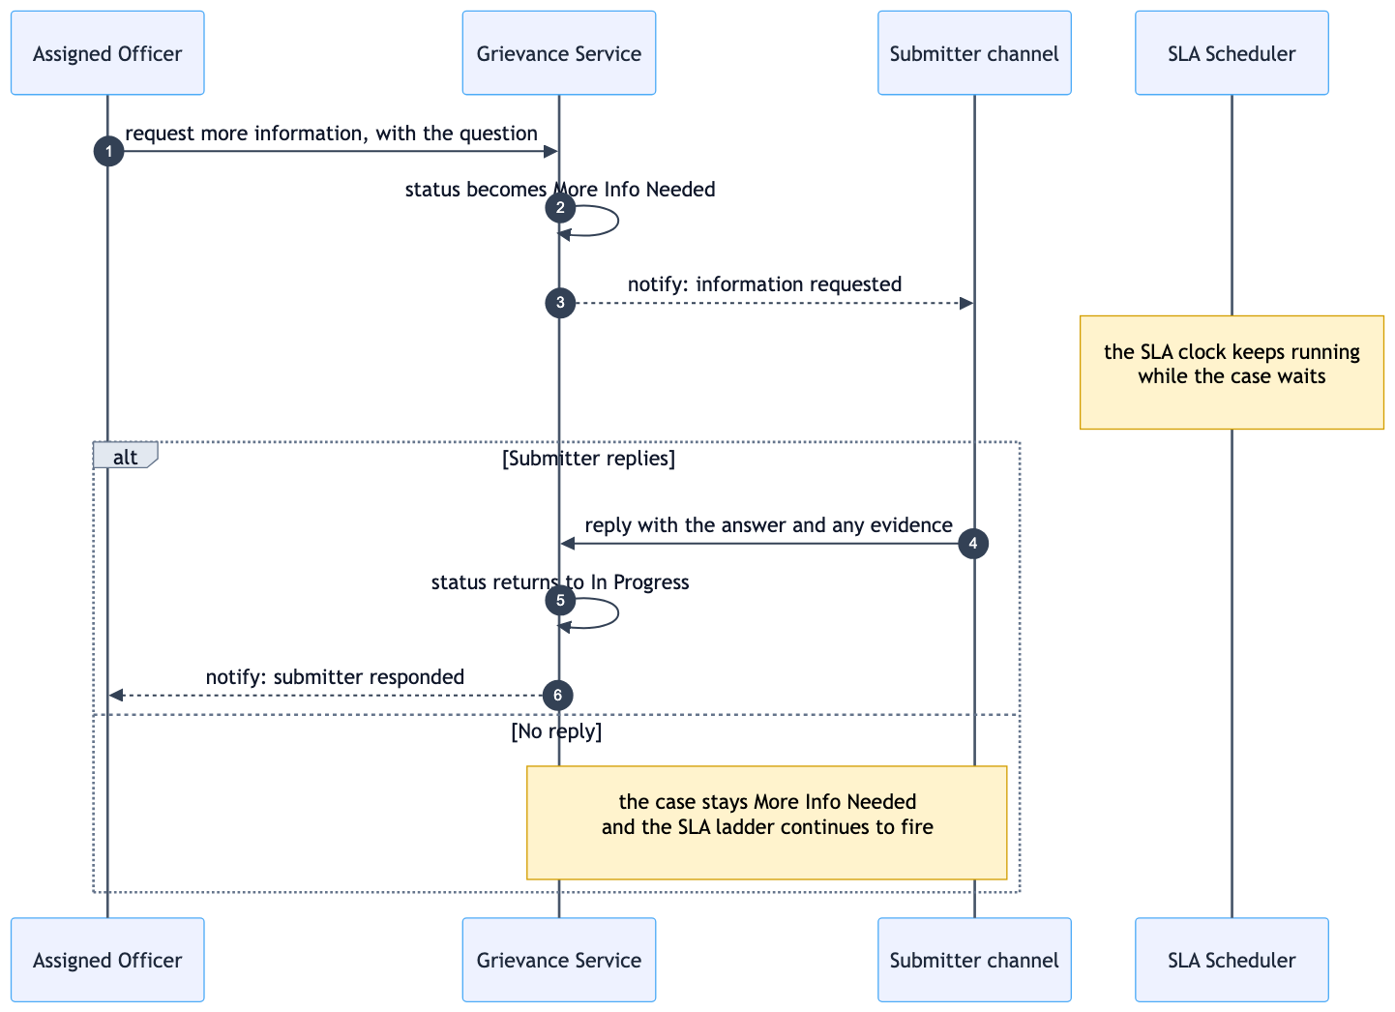
2.3.2 — the more info needed loop
The SLA clock does not pause while the case waits on the submitter. If no reply comes, the case stays in More Info Needed and the escalation ladder in 2.3.5 keeps firing against it.

2.3.3 — Duplicate review
Dedup marks a case rather than blocking it, so a person decides. Both outcomes are ordinary; neither is an error.
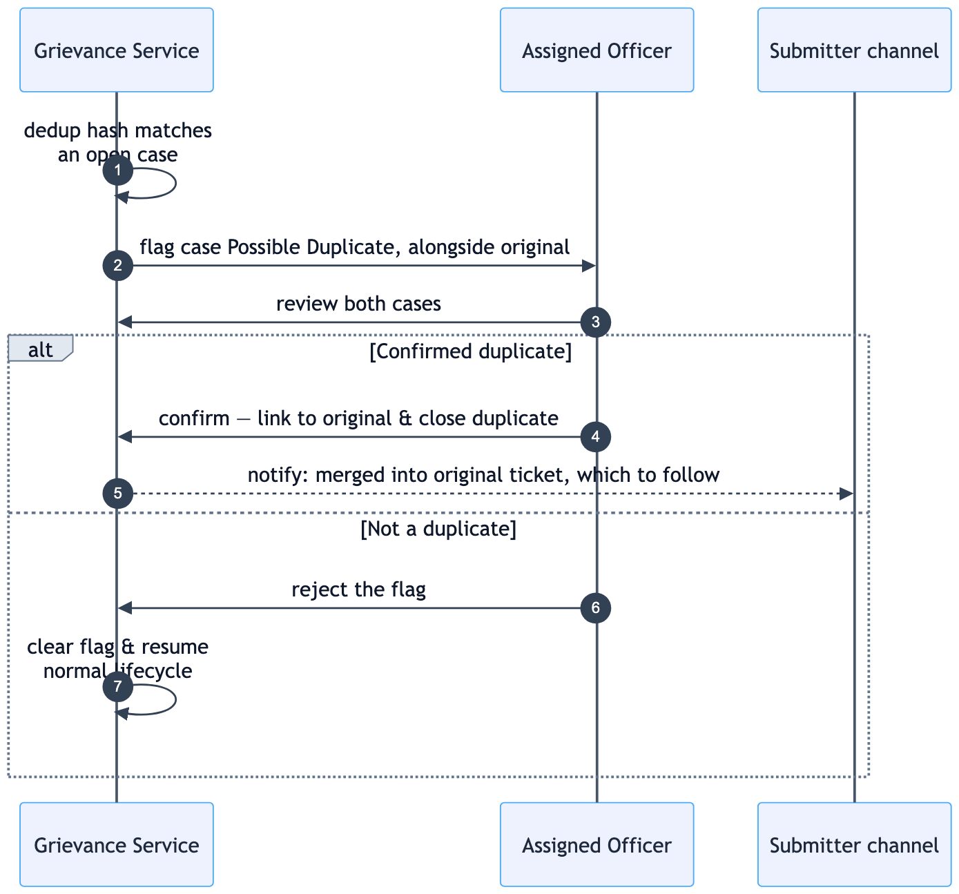
2.3.3 — duplicate review
A confirmed duplicate is closed against the original and the submitter is told which ticket to follow, so they are not left tracking a number that will never move.

2.3.4 — Referral and reassignment
Whether a move needs L2’s approval is a per-category setting, not a property of the move. It is off for every category by default — a reassignment or referral commits straight away — and an administrator or the owning department can turn it on for categories where a second pair of eyes is warranted.
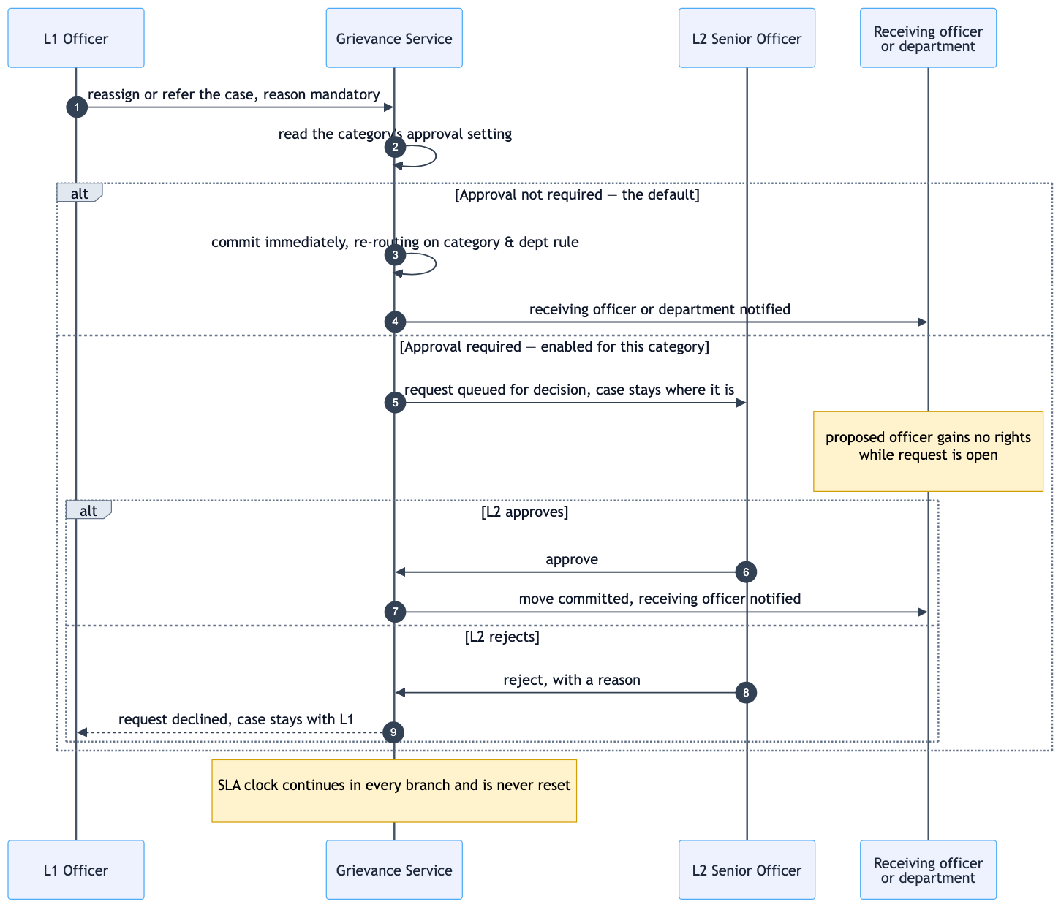
2.3.4 — referral and reassignment
With approval enabled, the case does not move while the request is open, and the proposed officer gains no rights over it — a pending request cannot be used to reach a case. The reason is mandatory either way, because it is what the audit trail records when nobody reviews the move. The SLA clock runs on regardless of which branch applies.

2.3.5 — The SLA ladder and escalation
The scheduler’s own loop, and the two ways a case becomes escalated.
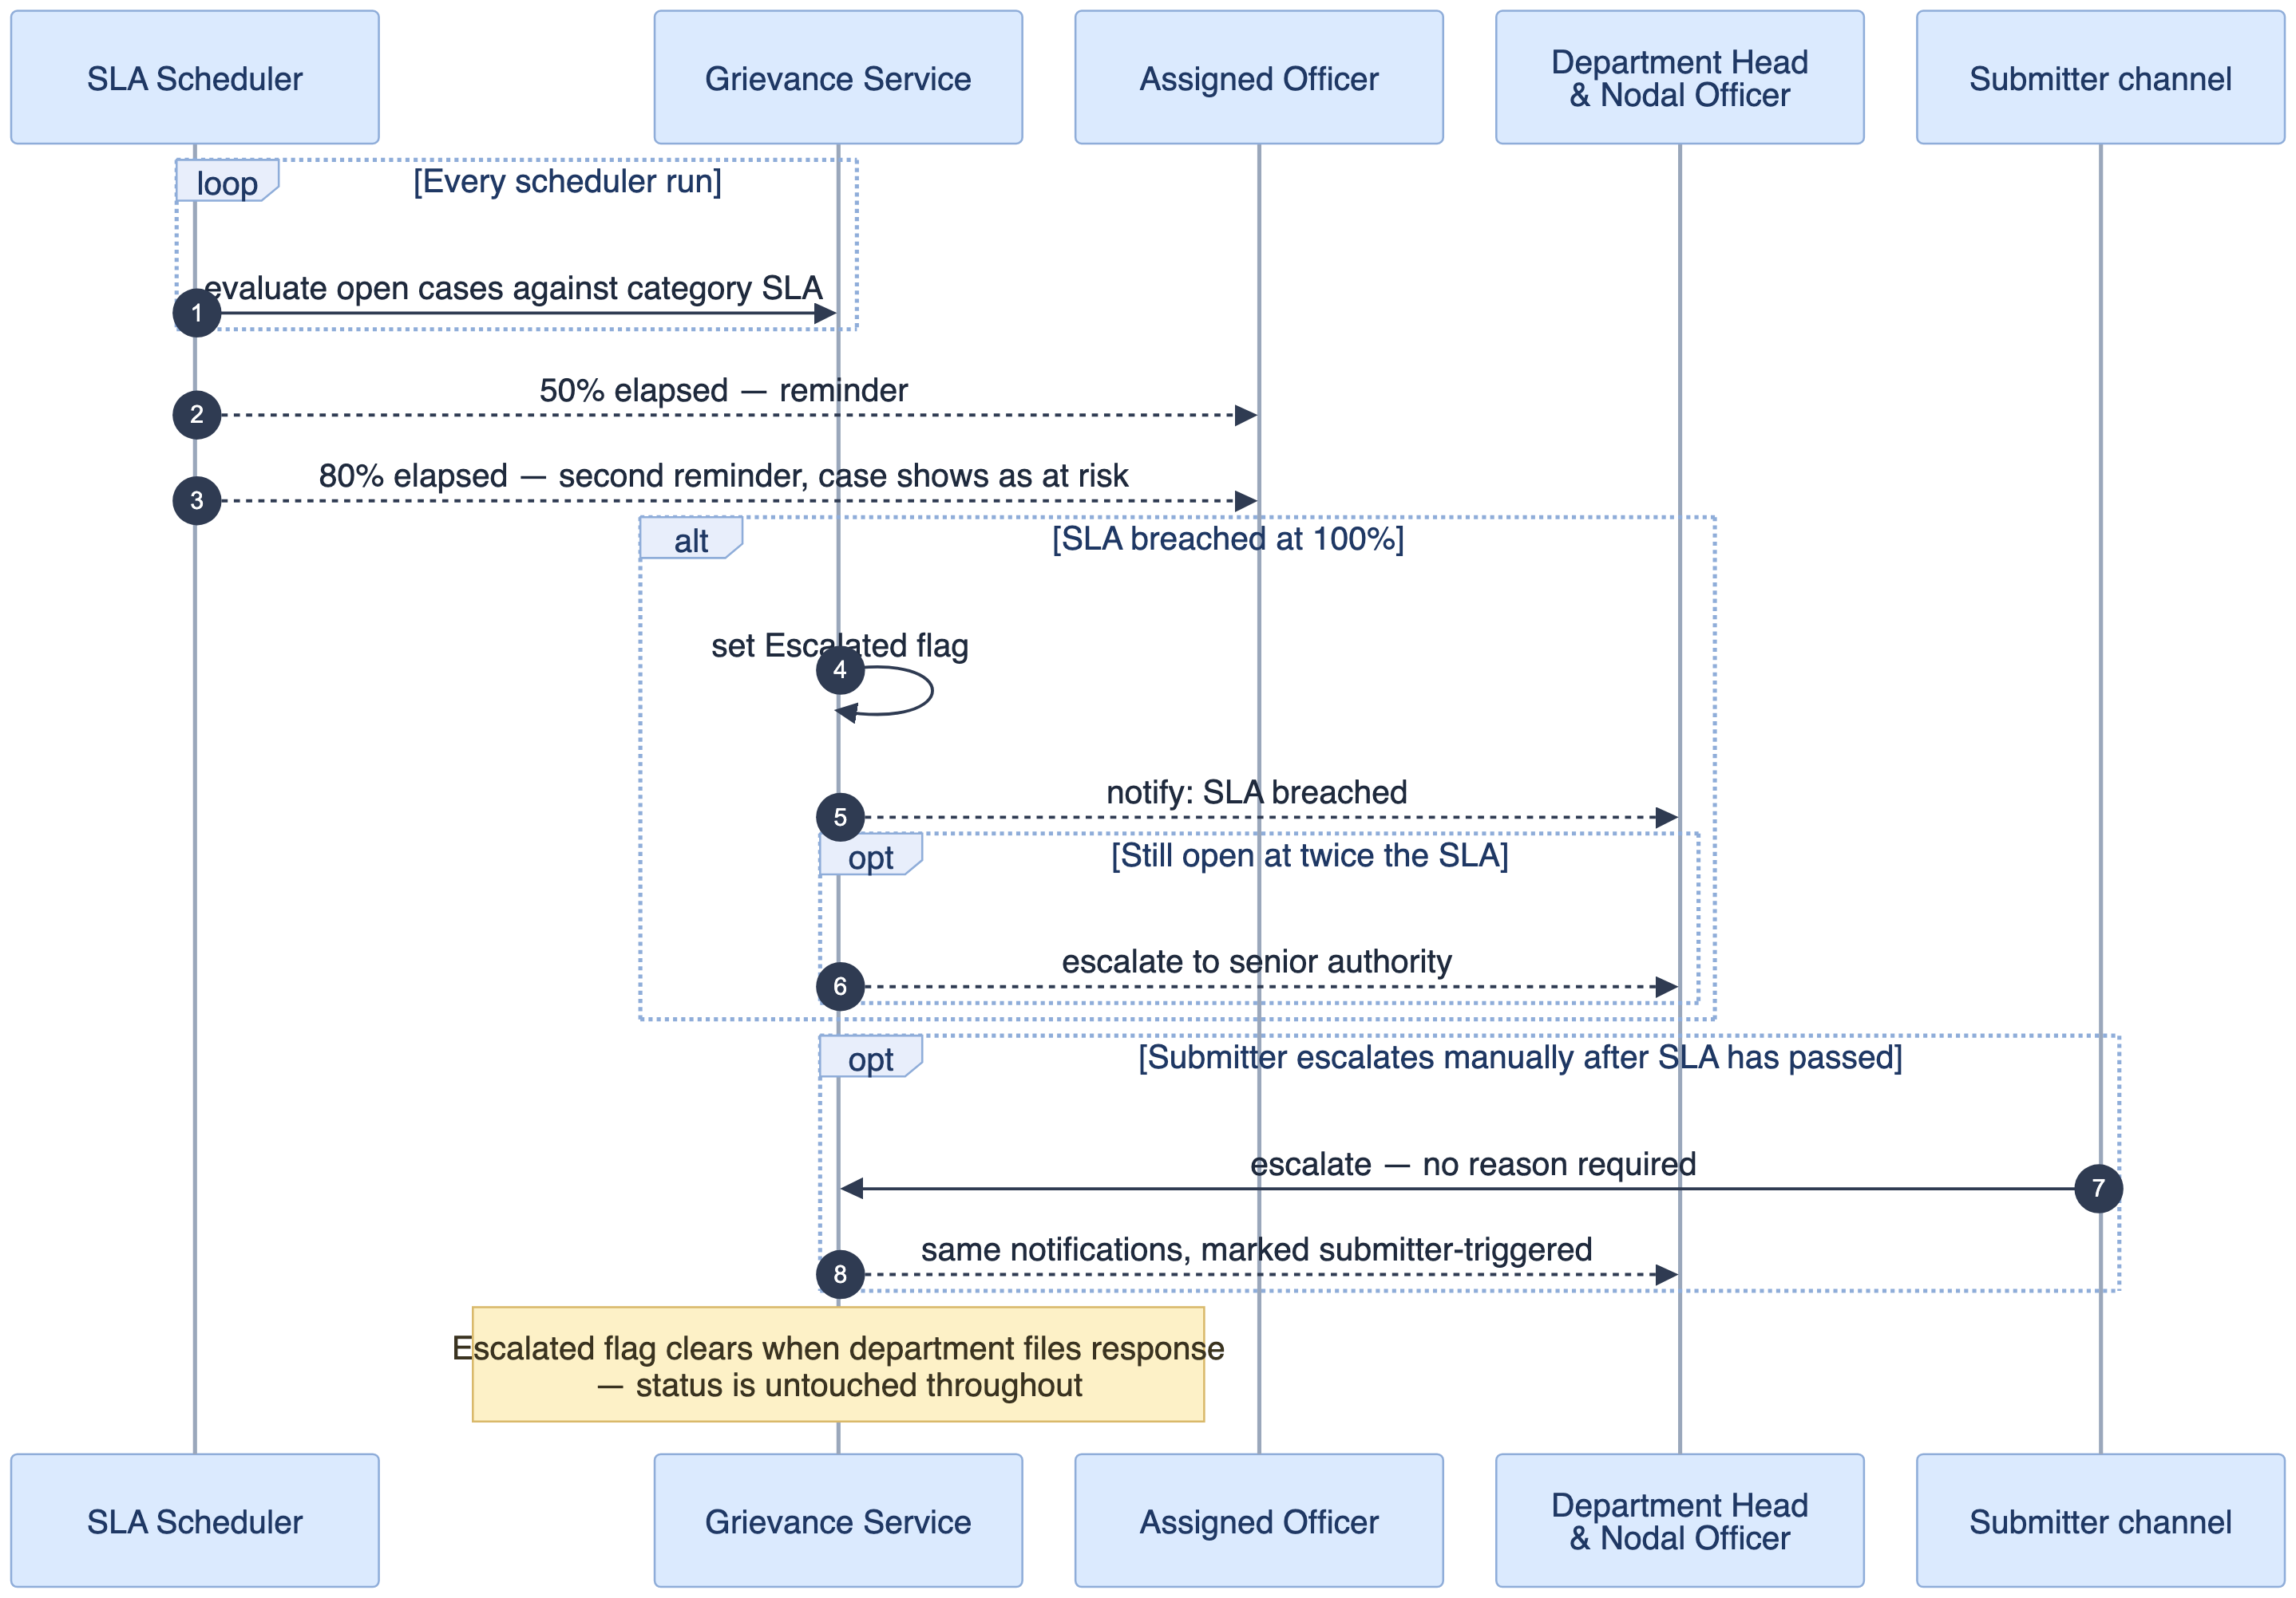
2.3.5 — the sla ladder and escalation
Escalation is a flag, not a status — it is set alongside whatever the case’s status happens to be, and clears when the department files its response. A submitter-triggered escalation produces the same notifications as a breach and is marked as such.

2.3.6 — Closure: confirm, reopen, or the window expiring
What the response opens, and the three ways it ends.
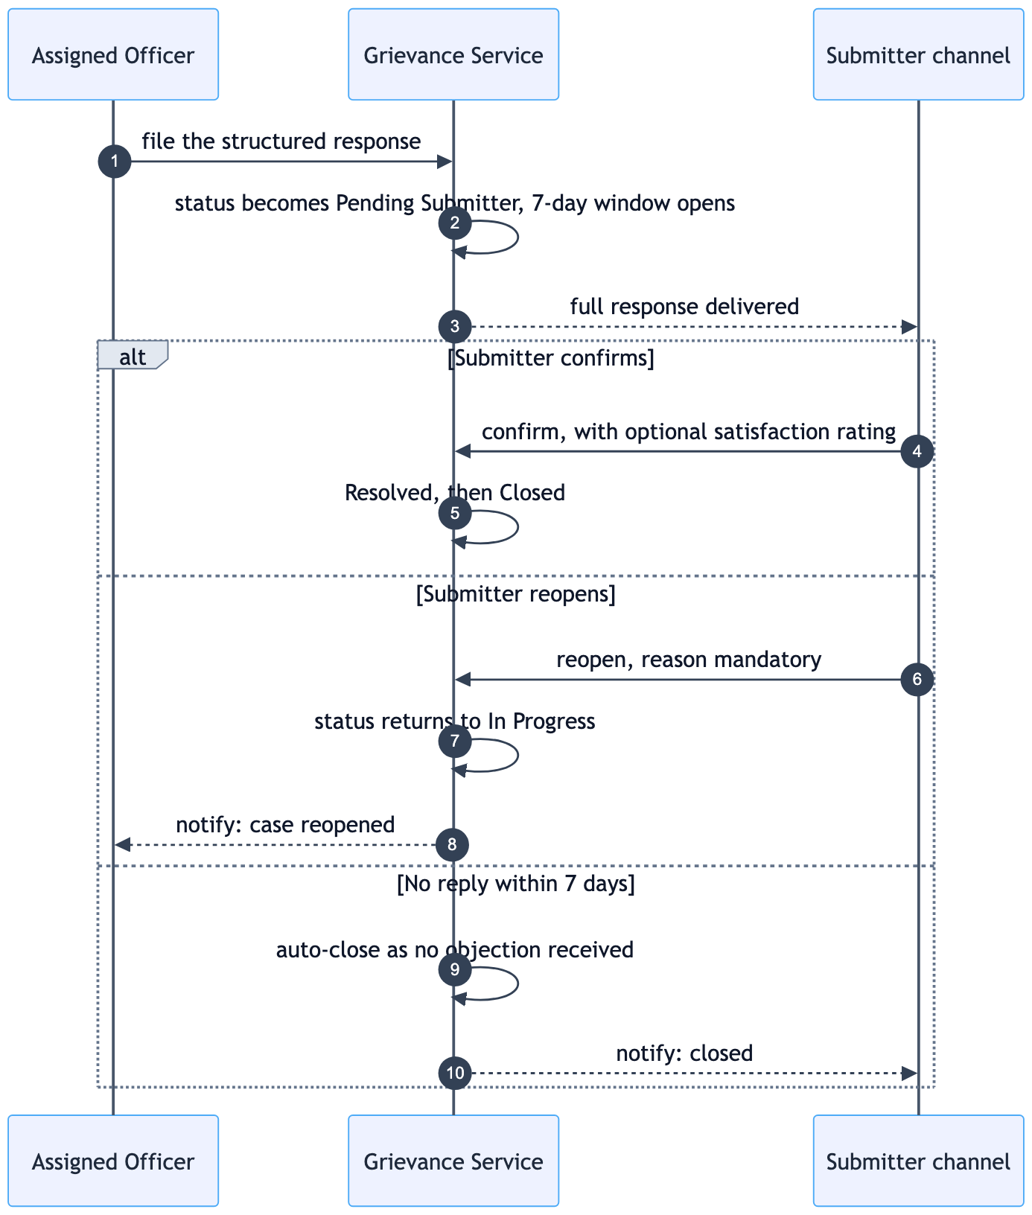
2.3.6 — closure: confirm, reopen, or the window expiring
Only one of the three branches involves the submitter doing something. The seven-day window closing on its own is a normal outcome, recorded as no objection received rather than as a confirmation.

2.3.7 — Attachment upload and scan verdict
Evidence is accepted before it is trusted. The upload returns immediately and the verdict arrives afterwards, so the interface has to represent a file that exists but cannot yet be opened.
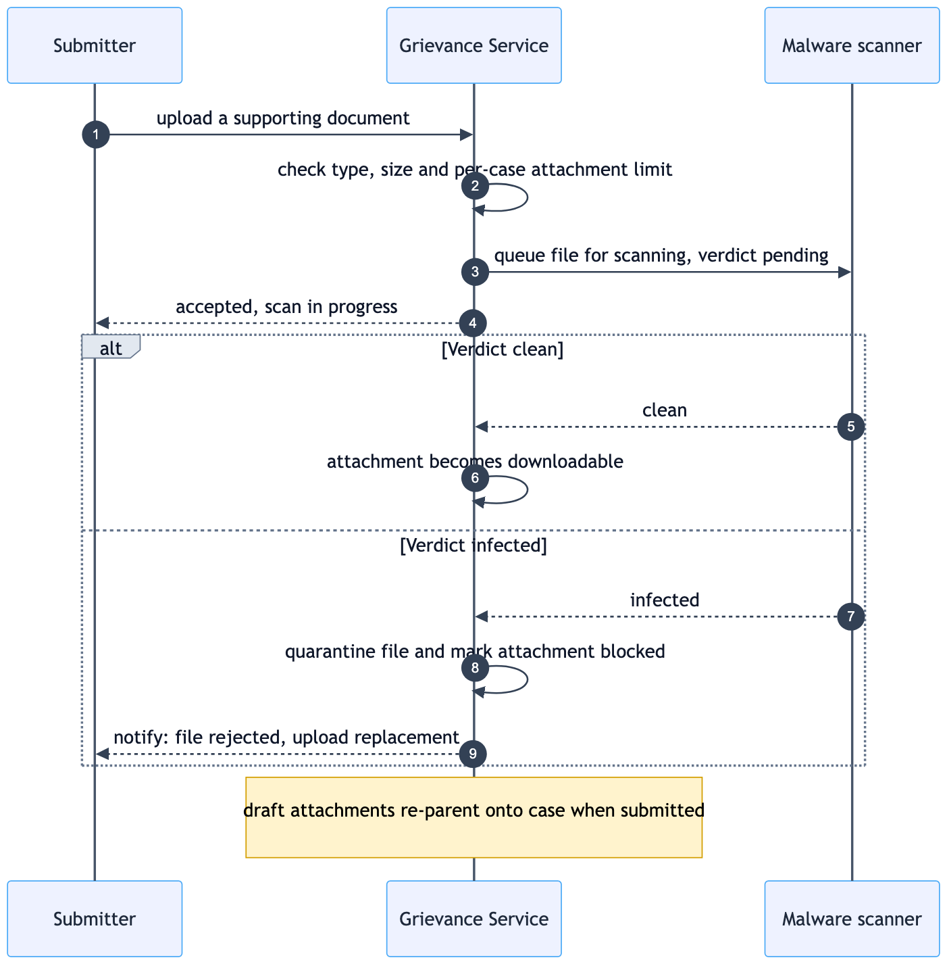
2.3.7 — attachment upload and scan verdict
An infected file is quarantined rather than silently dropped, and the submitter is told, because a farmer who believes their evidence is attached will not send it again. Files uploaded as supporting evidence are attached and linked to the case upon submission.

2.3.8 — Anonymity
A submitter who fears consequences can ask for their identity to be withheld from the people handling the case.
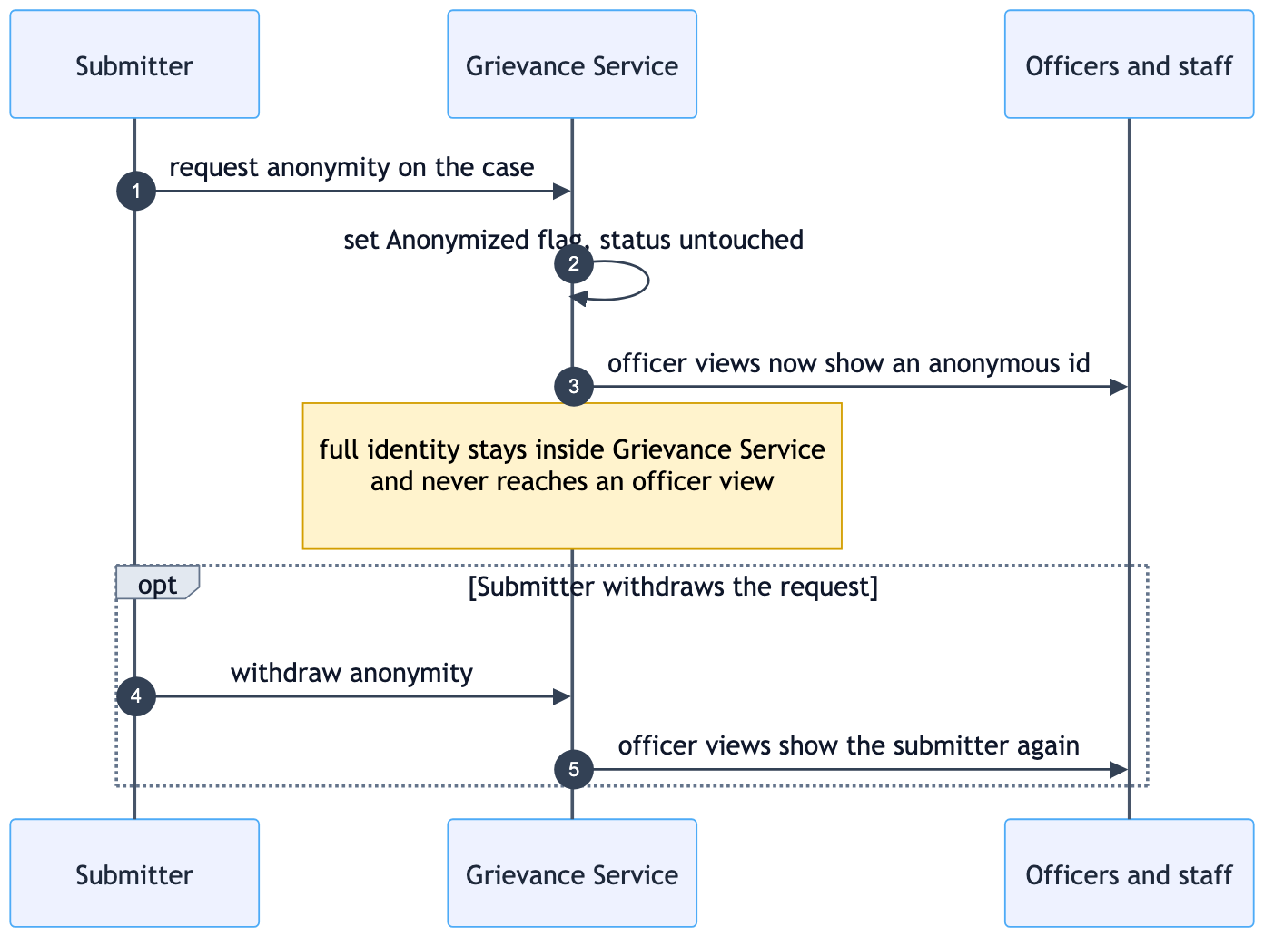
2.3.8 — anonymity
Anonymity is a flag like escalation, independent of status. It changes what officer views render, not what the service stores — the full identity stays inside the service and is never sent to an officer view.

2.3.9 — SLA deferral
An officer who cannot meet the SLA asks for more time rather than letting the case breach quietly. The request is governed by the category's deferral policy, which caps how many times one case can be deferred, and it is L2 who decides.
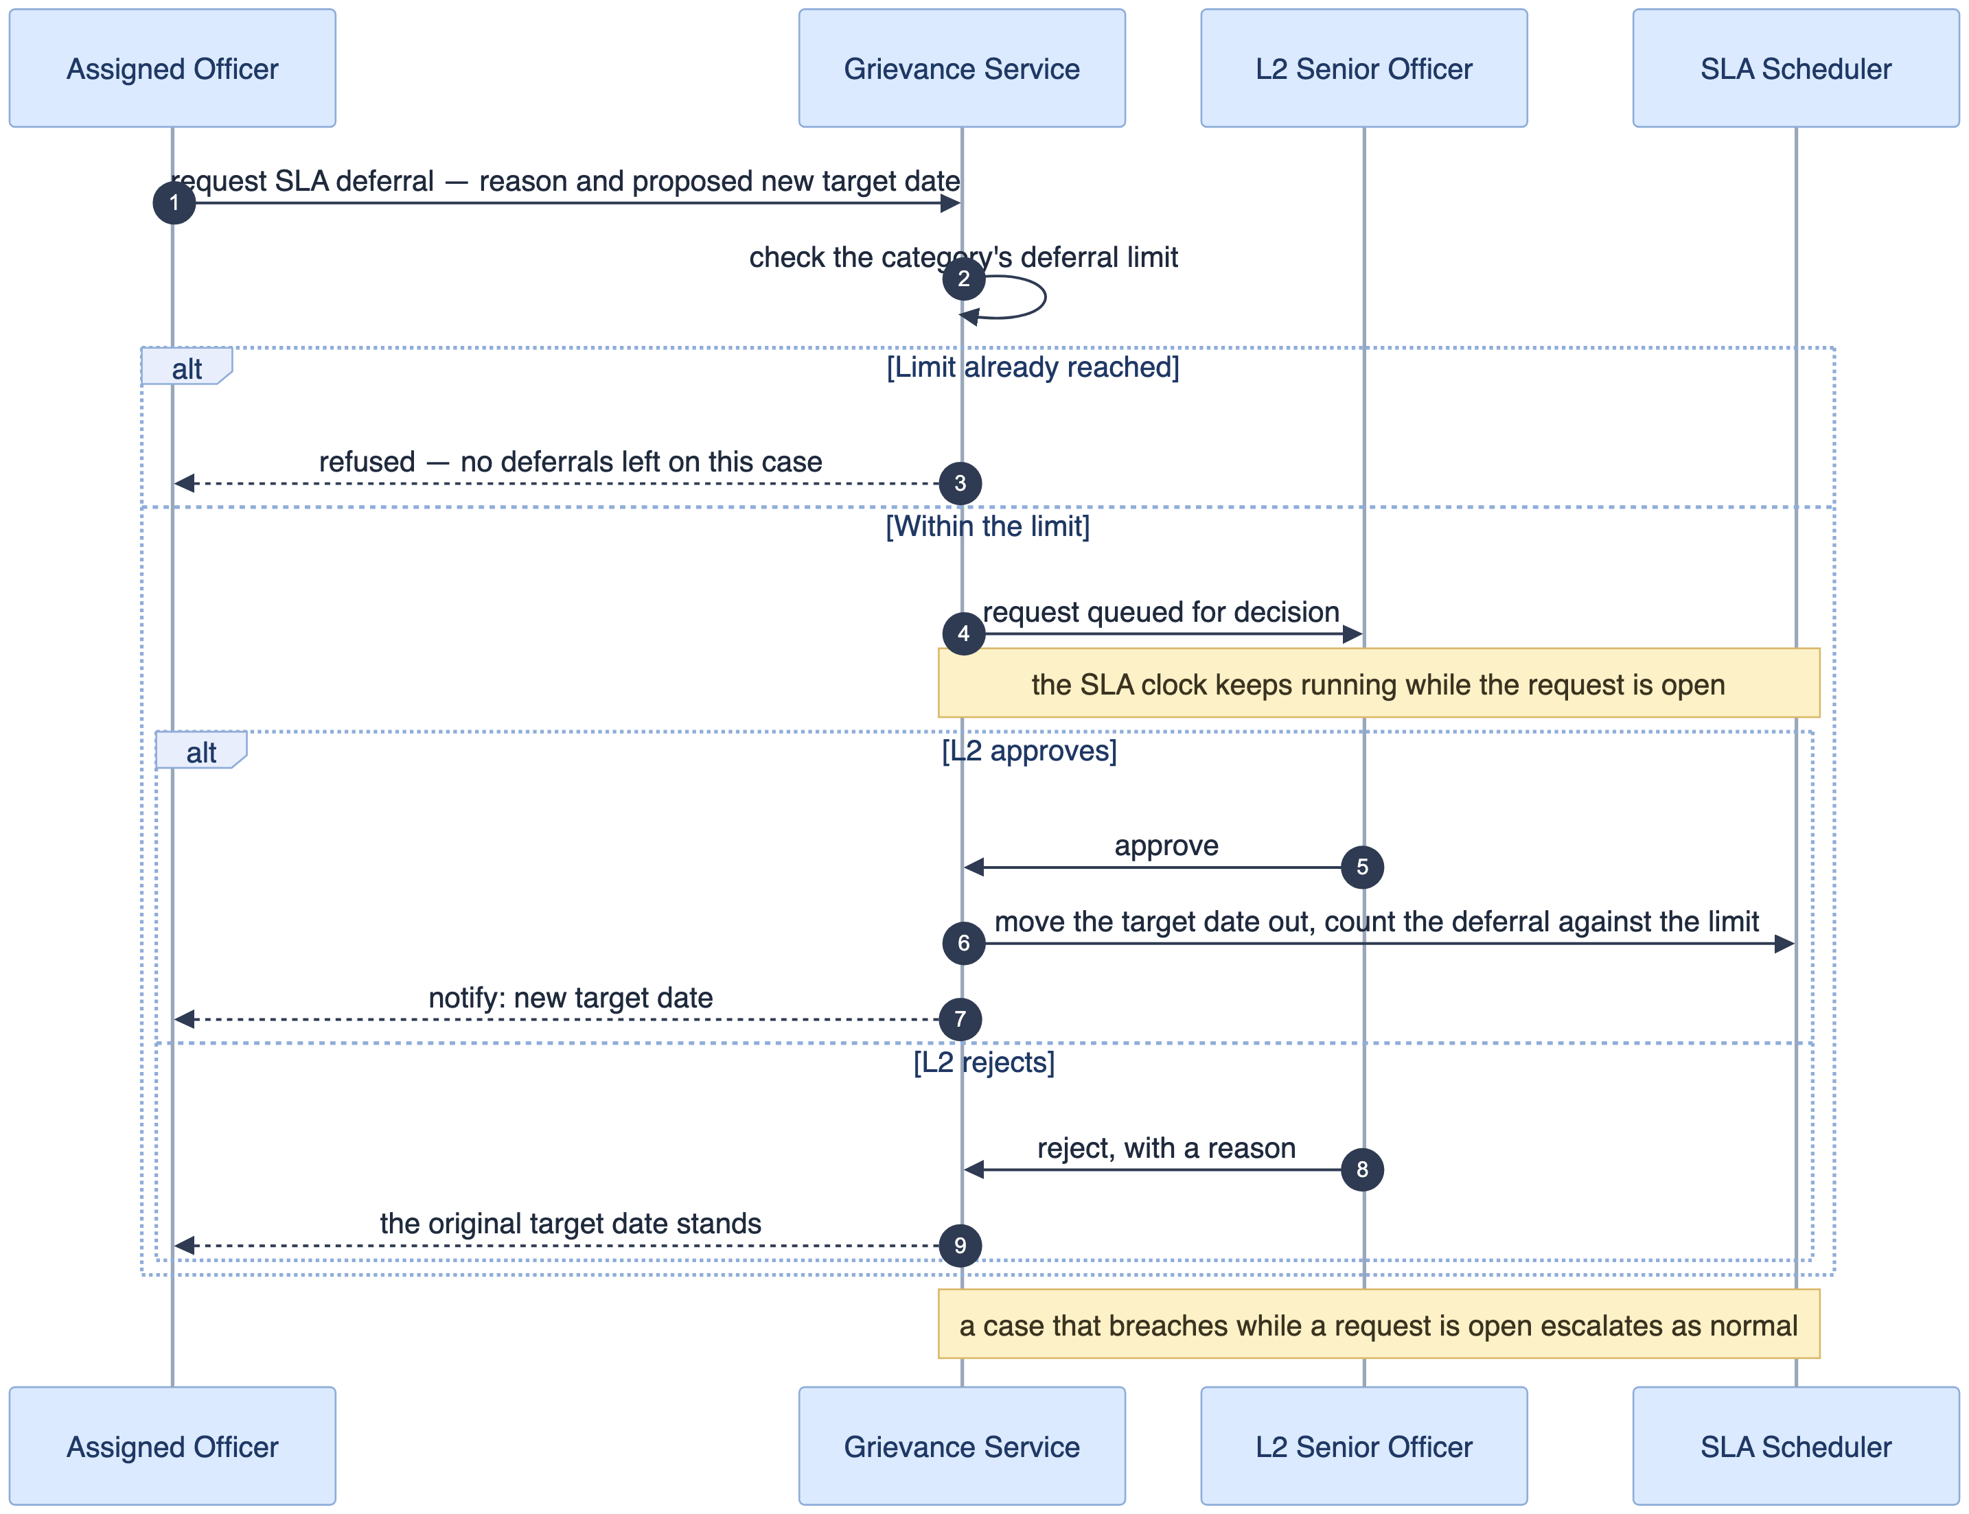
2.3.9 — SLA deferral
The clock does not stop while the request is open, so a pending deferral cannot be used to park a case — a deferral only moves the target date once L2 approves it. Approval counts against the category's limit, and a case that breaches while its request is open escalates exactly as it would otherwise.

3. REST API Catalogue
The service’s REST interface. Paths are relative to the gateway host. “Public” means the route is reachable without a bearer token. “Partner API key” means a channel service authenticates with its own credential rather than an end user’s token. Everything else needs an authenticated session, and role scoping is applied inside the service, not at the gateway.

3.1 Health & monitoring
Method | Path | Purpose | Access
GET | /api/v1/services/health | Health probe for containers and the gateway | Public
GET | /api/v1/services/ping | Uptime-monitor ping | Public

3.2 Administrative areas & reference data
Method | Path | Purpose | Access
GET | /api/v1/areas | Cascading area drill-down, or text search | Public
GET | /api/v1/areas/{area_id_or_path}/ancestors | Ancestor breadcrumbs for an area | Public

3.3 Case Submission
The case submission endpoint accepts filings across mobile app, web portal, and partner intake channels. It validates mandatory fields, verifies deduplication, mints the official ticket number, and triggers auto-routing in one direct step.
Method | Path | Purpose | Access
POST | /api/v1/cases | Submit a new case: records intake channel, submitter details, category, type, description, and attached evidence. Validates, checks deduplication, issues ticket number, and triggers auto-routing. | Authenticated submitter or Partner API key

3.4 Channel intake webhook
POST /api/v1/cases is the shared inbound receiver the IVR, mail and Telegram services call to create a case on a submitter’s behalf. It is the one creation path that does not come from a signed-in submitter, so it authenticates with a partner credential rather than a bearer token. Channel is recorded as an attribute of the case, which is what keeps all three services on one code path instead of three.
Method | Path | Purpose | Access
POST | /api/v1/cases | Create a grievance from a non-interactive channel; records the originating channel, validates, dedup-checks, issues the ticket number, triggers routing. A case that arrives without a category is filed under Other (2.3.1) | Partner API key, IP-allowlisted at the gateway
Submitters across all channels use the unified case submission route (POST /api/v1/cases).
A case arriving by SMS or email has no authenticated submitter. The person sent a message; they did not sign in, and the platform knows only the phone number or address the message came from. The case is created anyway — refusing it would mean turning away the submitters least able to use an app — and is recorded against an unverified contact.
The service then replies on the same channel with a standard verification message carrying the ticket number and a one-time link. From there the case takes one of two paths:
- The submitter verifies. They follow the link, sign in through single sign-on, and the case binds to their submitter profile. They can now track it in the app or the portal, see the full timeline, reply to information requests in the thread, and confirm or reopen the resolution.
- The submitter does not verify. The case proceeds as unauthenticated. It is routed, worked and answered exactly like any other, and every update still reaches the phone number or address it came from — but the contact stays unverified, there is no portal access, and the actions that depend on a known identity (confirming a resolution, reopening a case, requesting anonymity) are unavailable.
Method | Path | Purpose | Access
POST | /api/v1/cases/{ticket_number}/verify | Exchange the one-time token from the verification SMS or email for a session, binding the case to the submitter’s profile | Public, by one-time token
The token is single-use and expires, and the route is throttled by IP alongside the other pre-authentication routes. It must not reveal whether a ticket number exists to a caller holding the wrong token.

3.5 Cases — read
Method | Path | Purpose | Access
GET | /api/v1/cases | Work-queue list with filtering, pagination and sorting | Scoped by role
GET | /api/v1/cases/options | Public intake and submission options (submitter types, identity schemes, service categories, grievance types, intake channels, languages, dialing prefixes) | Public
GET | /api/v1/cases/{ticket_number} | Full case detail, visibility-filtered | Owner, assigned officer or admin

3.6 Cases — lifecycle, actions and communication
Method | Path | Purpose | Access
POST | /api/v1/cases/{ticket_number}/action | Unified workflow action endpoint: execute state transitions (Verify, Confirm, Reopen, Reject, Escalate, Assign) with reason, remarks, and optional rating | Owner, assigned officer or admin
POST | /api/v1/cases/{ticket_number}/message | Unified communication & response: post public messages, internal notes, info requests, submitter replies, or structured department responses driving workflow status | Owner or assigned officer (staff only for notes)
GET | /api/v1/cases/{ticket_number}/timeline | Timeline and conversation thread detail, visibility-filtered | Owner, assigned officer or admin

3.7 Attachments
Method | Path | Purpose | Access
POST | /api/v1/cases/{ticket_number}/attachments | Upload a supporting document to a case | Owner or assigned officer
GET | /api/v1/cases/{ticket_number}/attachments | List a case’s attachments with scan verdicts | Owner, assigned officer or admin
GET | /api/v1/cases/{ticket_number}/attachments/{attachment_id}/download | Signed file URL for a clean attachment | Owner, assigned officer or admin
DELETE | /api/v1/cases/{ticket_number}/attachments/{attachment_id} | Remove an attachment from an open case | Uploader or admin

3.8 Administration — users, organisation and routing
Admin-only configuration — the API surface behind 2.1 and 2.2. These routes back the Administration and User Management screens, and write to the Grievance Department, Grievance Service Category, Grievance Type, Grievance Routing Rule, Grievance SLA Configuration and Grievance RBAC Assignment entities.

Officers and users
There is no self-registration. The admin creates the account and the service issues a temporary password, which the officer replaces at first sign-in (2).
Method | Path | Purpose | Access
POST | /api/v1/users/officers | Create an officer with role level (L1 / L2 / Department Head) and department, category and area scope; issues the temporary password | Admin
GET | /api/v1/users/officers | List officers, filterable by role level, department and scope | Admin
GET | /api/v1/users/officers/{officer} | Officer detail with the current RBAC assignment | Admin
PATCH | /api/v1/users/officers/{officer} | Change role level, scope or active flag | Admin
POST | /api/v1/users/officers/{officer}/reset-password | Reissue a temporary password | Admin
GET | /api/v1/users | Every user the caller may see — an admin gets all of them, a department head gets their own department, and ?department= narrows further. Backs the User Management table (name, email, role, region, cases handled, active flag) | Admin or department head
GET | /api/v1/users/summary | Counts for the User Management KPI cards: total, active, inactive, and the split by role level, within the caller’s scope | Admin or department head
GET | /api/v1/users/options | Dropdown options and reference data for user & officer creation (roles, departments, role levels, administrative areas) | Admin or department head

Departments
Method | Path | Purpose | Access
POST | /api/v1/departments | Create a department with its notification email, phone and head / senior / nodal officers | Admin
GET | /api/v1/departments | List departments | Admin
GET | /api/v1/departments/{department} | Department detail | Admin
PATCH | /api/v1/departments/{department} | Update details, officers or the active flag | Admin
DELETE | /api/v1/departments/{department} | Retire a department with no open cases | Admin

Service categories and grievance types
Exactly one category is the default at any time — Other, unless an administrator names another. It is a flag on the category, set when the category is created or switched later; promoting a category clears the flag on the previous one. The default cannot be deactivated while it holds that role.
Method | Path | Purpose | Access
POST | /api/v1/service-categories | Create a category with its name, code, sort order and whether it is the default — the one unclassified cases fall to | Admin
GET | /api/v1/service-categories | List categories | Admin
PATCH | /api/v1/service-categories/{category} | Rename, reorder, deactivate, or make this the default category | Admin
POST | /api/v1/grievance-types | Create a grievance type under a category | Admin
GET | /api/v1/grievance-types | List types, filterable by category | Admin
PATCH | /api/v1/grievance-types/{type} | Rename or deactivate | Admin

RBAC assignment rules and SLA policy
Method | Path | Purpose | Access
POST | /api/v1/rbac-assignments | Link category, type, provider, and administrative area to an owning department and officer roster | Admin
GET | /api/v1/rbac-assignments | List RBAC assignment desks and routing scopes | Admin
PATCH | /api/v1/rbac-assignments/{assignment} | Change target department, scopes, officer roster, or active flag | Admin
DELETE | /api/v1/rbac-assignments/{assignment} | Remove an assignment desk | Admin
PATCH | /api/v1/service-categories/{category}/reassignment-approval | Turn L2 approval for reassignment and referral on or off for a category. Off for every category by default | Admin or department head
POST | /api/v1/sla-configurations | Set SLA days, first-response hours, update cadence, auto-escalation threshold, deferral limit and appeal window for a category | Admin
GET | /api/v1/sla-configurations | List SLA configurations by category | Admin
PATCH | /api/v1/sla-configurations/{config} | Adjust thresholds or the escalation authority | Admin

3.9 Response templates
A template is scoped by service category and response type — Resolved, Partially Resolved, Referred to another dept, Requires further info — and carries a pre-written action taken and resolution summary. The officer-facing load is the one that matters day to day: when an officer picks the response type they are about to file, the console fetches the templates that match that type and the case’s category, rather than making them scroll the whole library.
Method | Path | Purpose | Access
POST | /api/v1/response-templates | Create a template for a category and response type, with action taken and resolution summary | Admin
GET | /api/v1/response-templates | List templates, filterable by service_category, response_type and is_active | Admin
GET | /api/v1/response-templates/{template} | Template detail | Admin
PATCH | /api/v1/response-templates/{template} | Edit the body, retitle, or deactivate; bumps the version | Admin
DELETE | /api/v1/response-templates/{template} | Remove an unused template | Admin
GET | /api/v1/cases/{ticket_number}/response-templates | Load the active templates that apply to this case, filtered by ?response_type= — what the officer sees when drafting a response | Assigned officer

3.10 Notification configuration
The Administration console carries a Notification Config tab: one row per lifecycle event (submission received, duplicate detected, status change, SLA reminder, escalation, resolution), each with its channels (SMS / Email), subject, recipient list, trigger and a templated body with {{ticket}}-style placeholders. Delivery is recorded separately in the notification log; these routes govern the configuration.
Method | Path | Purpose | Access
GET | /api/v1/notification-configs | List the event notification configurations | Admin
GET | /api/v1/notification-configs/{event} | One event’s configuration, with its rendered template | Admin
PATCH | /api/v1/notification-configs/{event} | Edit channels, subject, recipients, trigger or body; toggle active | Admin
POST | /api/v1/notification-configs/{event}/preview | Render the template against a sample case, to check placeholders before saving | Admin

3.11 Reports & analytics
Three separate consumers, each with its own aggregation.
Main dashboard — KPI tiles (total, awaiting action, resolved, escalated, each with a period-over-period trend), a monthly submitted-vs-resolved trend, a status distribution, a service-category mix, and a recent-cases list.
Case-list metric cards — counts per status bucket (all, pending, in progress, under review, resolved, rejected) above the work queue. These must be aggregated server-side over the whole filtered set: counting client-side can only reach the page already loaded, so the tiles would disagree with the real totals as soon as the list paginates.
Analytics & Reporting — average resolution time, resolution rate, escalation rate and farmer satisfaction as KPI tiles, plus weekly submissions, resolution rate by region, and volume by service category.
Method | Path | Purpose | Access
GET | /api/v1/cases/summary | KPI summary tiles and status counts with period-over-period trend, scoped to the caller’s department and area | Staff
GET | /api/v1/reports/trend | Submitted vs resolved per month/week over a window | Staff
GET | /api/v1/reports/status-distribution | Case distribution per lifecycle status | Staff
GET | /api/v1/reports/category-distribution | Case distribution per service category | Staff
GET | /api/v1/reports/kpis | Average resolution time, SLA compliance, escalation rate, and satisfaction against previous period | Staff
GET | /api/v1/reports/submissions | Submission volume by intake channel and week | Staff
GET | /api/v1/reports/resolution-by-region | Resolution rate per administrative area | Staff
GET | /api/v1/reports/volume-by-category | Case volume per service category and department | Staff
POST | /api/v1/reports/export | Queue a CSV or PDF export of the current filter selection | Staff
Every one of these should accept the same date-range, department, category and area parameters, and should be scoped by the caller’s RBAC assignment rather than trusting a department parameter from the client.

3.12 Case triage & SLA operations
The operations the case detail sidebar performs, beyond the conversation and lifecycle routes in section 3.6.
Method | Path | Purpose | Access
POST | /api/v1/cases/{ticket_number}/duplicate-decision | Confirm or reject the Possible Duplicate flag | Assigned officer
POST | /api/v1/cases/{ticket_number}/defer-sla | Request an SLA deferral against the deferral policy, with a reason and a new target date | Assigned officer
POST | /api/v1/cases/{ticket_number}/reassignment-requests | Move the case to another officer or department, reason mandatory. Commits immediately unless the category requires approval, in which case it queues for L2 and the target gains no rights until approved | L1 officer
POST | /api/v1/reassignment-requests/{request}/decision | L2 approves or rejects a queued request; only an approval commits the move. Reached only where the category requires approval | L2 officer
POST | /api/v1/cases/{ticket_number}/anonymity-request | Raise or withdraw an anonymity request on a case | Owning submitter
The primary case interactions are unified under POST /api/v1/cases/{ticket_number}/message (which handles notes, public conversation, info requests, and structured formal department responses driving next status) and POST /api/v1/cases/{ticket_number}/action (which executes state transitions such as Confirm, Reopen, Reject, Escalate, and Assign). The specialized operations above manage triage duplicates, SLA deferrals, multi-level reassignment approvals, and anonymity requests.

3.13 Identity, sign-in and session
Part of the same platform surface, behind the same gateway. There is no self-registration for an individual submitter. A farmer or a Development Agent arrives through single sign-on: the identity already exists, and the platform provisions a submitter profile against it on first sign-in rather than asking the person to create an account.
An organisation — an NGO, an FPO or a cooperative — is the one case that registers. The representative creates a personal account with POST /api/v1/auth/register, then signs in and submits the organisation’s account request from it. The two steps are separate on purpose: registration establishes a person the platform can correspond with, and the organisation request is what an administrator reviews. The organisation gets no standing until that review approves it.

Sign-on
Method | Path | Purpose | Access
GET | /api/v1/auth/sso/authorize | Begin single sign-on; returns the provider redirect for the client to follow | Public
POST | /api/v1/auth/sso/callback | Exchange the provider’s authorisation code for a platform token pair; provisions the submitter profile on first sign-in | Public
POST | /api/v1/auth/register | Register a personal account — the route an organisation representative uses before requesting an organisation account. Not a path a farmer or Development Agent takes | Public
POST | /api/v1/auth/login | Sign in with credentials — officers, administrators, registered representatives and approved organisation accounts | Public
POST | /api/v1/auth/refresh | Exchange a single-use refresh token for a fresh pair | Public
POST | /api/v1/auth/logout | Revoke the refresh token and end the session | Public
POST | /api/v1/auth/forgot-password | Begin password recovery | Public
POST | /api/v1/auth/reset-password | Complete a password reset — also the route an officer uses to replace the temporary password issued in 2.2 | Public
GET | /api/v1/auth/me | The current user: identity, roles and scope | Authenticated
GET | /api/v1/auth/keys | Public key material for verifying issued tokens | Public
GET | /api/v1/auth/health | Service health probe | Public
GET | /api/v1/auth/metadata | Aggregated form and reference metadata for the sign-in screens | Public

Organisation account requests (NGO / FPO / cooperative)
Method | Path | Purpose | Access
POST | /api/v1/auth/organisation-requests | Submit an organisation account request: legal name, registration number, type, administrative area and supporting documents. The signed-in registrant is recorded as the contact person | Registered representative
GET | /api/v1/auth/organisation-requests | The requests the signed-in representative has submitted, with their current status | Registered representative
GET | /api/v1/auth/organisation-requests/{request} | One request in full, including the decision and any rejection reason | Registered representative, own request
GET | /api/v1/users/organisation-requests | Review queue, filterable by status and administrative area | Admin
GET | /api/v1/users/organisation-requests/{request} | Full request with its supporting documents | Admin
POST | /api/v1/users/organisation-requests/{request}/decision | Approve or reject with a mandatory reason; approval creates the organisation and binds the requesting account to it as its first representative | Admin
Rejection is a decision the requester can act on, so the reason is mandatory and is returned on the status check. Until a request is approved, the representative’s account exists but carries no organisation role and can raise nothing on the organisation’s behalf. On approval the organisation is created and the representative’s account is bound to it, so no second credential is issued and no second sign-in is needed.
The sign-on and recovery routes are the pre-authentication surface, so they are the ones the gateway throttles by IP rather than by consumer. GET /api/v1/auth/keys is what lets the gateway validate a token’s signature without calling back into the platform on every request.

4. OpenAPI Specification
The machine-readable contract is openapi/openapi_v1.public.yaml (OpenAPI 3.0.3, OAN Grievance Service API, version 1.0.0), generated by openapi/generate_openapi_spec.py. It is the single description of the interface: every route in section 3, with its parameters, request bodies, response envelopes and authentication scheme.
The spec is also the input to the gateway configuration. kong/generate_kong_config_from_spec.py reads paths, methods and authentication straight out of it, so a route that is not in the spec gets no gateway route at all. Two consequences worth designing for:
- Each route’s authentication scheme must be stated in the spec, not assumed. POST /api/v1/cases is a partner-key route rather than a bearer-token one, and the gateway will only front it correctly if the spec says so.
- The order of work is spec first, then gateway. Generate the contract, review it, then generate kong.yml from it.

5. API Gateway (Kong) Overview

5.1 One hop, gateway in front of the platform
Channel / Partner → Kong Gateway → Grievance Platform
TLS · authn · REST facade + application
throttling · logic, one codebase
routing
Kong fronts the platform directly — there is no separate service in between. Its job stays narrow and mechanical: TLS termination, token validation, rate limiting, CORS, request-size limits, routing and observability. Request shape and business logic stay in the platform, versioned and tested with the rest of the code rather than pushed into gateway plugin config.

